Red Blood Cell and Sickle Cell Detection from

Microscopic Blood Images of Sickle

Cell Anemic Patient

***Abstract***

***s***ickle cell anemia (SCA) is a type of haemolytic anemia which is the most commonly inherited blood disorder.Detection of red blood cell and sickle cell from sickle cell anemic person is a very challenging task. Besides traditional visual inspection of microscopic images, various methods have been developed which are based on image processing technique for faster and more accurate diagnosis of SCA. In this paper normal and abnormal red blood cells have been detected using Niblack’s thresholding technique from microscopic blood images of sickle cell anemic patient. The process involves preprocessing of microscopic blood smear and segmenting the preprocessed image using Niblack’s thresholding algorithm. Then using geometrical features of blood cells a metric (form factor) is calculated to classify normal red blood cells and abnormal cells. *Index Terms*—Sickle cell anemia (SCA), red blood cell, Niblack’s thresholding, form factor.

1. **INTRODUCTION**

In human blood, red blood cells (RBCs) are the most copious cell type. The key function of RBC is distribution

of oxygen to body tissues. They bring waste carbon dioxide back to the lungs. RBCs are biconcave so they have

large surface area for gaseous exchange. They can easily pass through narrow capillary blood vessels because of their elasticity. RBCs contain enormous amounts of a protein called hemoglobin. The oxygen binds with this iron containing molecule and enter blood vessels in the lungs. The development of sickle shaped cell is result of the mutation in the hemoglobin gene which leads to sickle cell disorder. In this disorder, sickle shaped cells are rigid and get trapped in blood vessels. Therefore normal blood movement gets blocked in human body. That will affect our health tremendously causing pain and organ damage [1], [2]. Sickle cell disease (SCD) is a genetic blood disorder. Children with this disorder have two defective hemoglobin S genes (sickle cell gene), carrying one

from each parent. There are different forms of sickle cell disorder. A person is said to have sickle cell trait when he/she inherits an imperfect hemoglobin S gene and usual hemoglobin A gene. They do not show symptoms of sickle cell disease, and their bodies do not produce rigid sickle shaped blood cells. But these people can carry the imperfect hemoglobin S gene to their next generation. SCD affects millions of people around the world, mainly sub-Saharan Africa, Saudi Arabia, Spanish-speaking countries, India and Mediterranean countries [3]. This disorder is prevalent among many tribal population groups in India mainly in Madhya Pradesh, Odisha,

Gujarat, Chhattisgarh, Rajasthan, Jharkhand, Andhra Pradesh, Assam and West Bengal [4]. For diagnosis of some specifific diseases like malaria, leukemia and different types of anemia, normal blood cells detection and counting are the most important steps. The counting of RBCs manually in microscopic images is an enormously tiresome and also time consuming which gives incorrect results. To perform faster and more accurately, automatic

analysis of microscopic blood images is very important [5].These problems are solved by applying different quantitative digital image analysis on microscopic blood images for classifification of normal cell and abnormal cell.Various works have been reported for counting normal blood cells from abnormal cell using different image processing methodologies [6]–[9]. N. H. Mahmood *et. al.* offered an approach that estimate the amount of RBCs using shape of the RBC, and Hough transform is applied in the process [10].In [5], author presented a way for segmenting and making a count of the WBCs as well as the RBCs that uses an algorithm of iterative structured circle detection. C. Dai *et al.*extracted spectral features of blood cell which will be used for segmentation and categorization of cells [11]. In [12], the researchers calculated statistical, geometrical and moment

invariant features in the detection of normal and abnormal blood cells. S. M. Mazalan *et. al.* presented Circular Hough Transform (CHT) for counting total number of RBC present in smear image of blood. They fifirst pre-processed the image.For getting the maximum and minimum radius of cell they cropped the image and then segmentation of an image of single cell RBC was done. Finally counting of the RBC is done by the application of CHT method [13].From previous literature on detection of normal RBC and sickle cell, it is found that different segmentation and morphological techniques are used from blood smear of sickle cell anemic person. Aruna N. S *et al.* proposes an approach to classify normal and abnormal RBCs by determining the highest, lowest and mean radius of each of these cells [14]. In [15],P. Rakshit *et al.* has presented a work that uses Weiner filter and Sobel Edge method for detecting the boundary of the corpuscles which identify the abnormalities in various param

eters of RBCs in an anemic case. In order to diagnose the

disease, the region properties of the corpuscles are then cal

culated for determination of their abnormal shape. In [16],

**Flow chart for the detection of RBC**

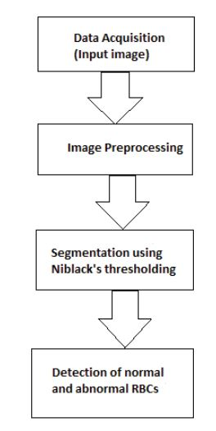

author proposed algorithm derived from CHT and a few morphological tools for detection of different types of anemia. S. Bala *et al.* have applied Watershed Segmentation technique on images for counting usual and

unusual cells. They calculated the form factor for each of these cells to classify usual and unusual cell and for visualization contour plot is drawn for RBC cell, Sickle cell, and Target Cell [17]. In this paper,Niblack local thresholding algorithm is implemented for preprocessing microscopic blood images to segment normal and abnormal RBCs. Abnormal blood cells are detected based on form factor. The form factor calculates whether the shape of the cell is circular or non-circular. In case of non-circular cell, it is considered as an abnormal cell. The remaining part of the paper is structured as given. Section II explains about the methods used in this paper. Section III provides details of experimental results. Finally, conclusion is provided in fourth section.

1. **METHODOLOGY**

The flowchart shows the flflow chart of detection of normal RBC

from blood smear of sickle cell anemic person. The process of

RBC detection in microscopic images consists of preprocess

ing, segmentation and then detection using form factor. Red

blood cells detection is the process to differentiate between

normal RBC and sickle cell in microscopic blood image.

***A. Data Acquisition***

In this work we have used samples collected from online

medical library [18]–[20]. One such sample of microscopic

blood image is shown in Fig. 2. These images are enhanced

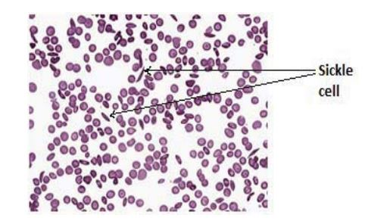

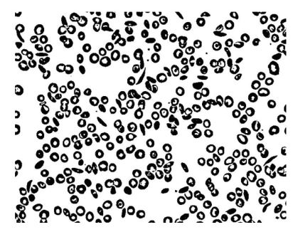

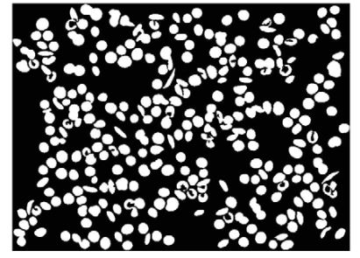

for further analysis. Therefore pre-processing is done before

feeding into the segmentation process.

1. ***Image Preprocessing***

Pre-processing of image is an essential step in image pro

cessing so that the image is set for further actual processing.

Image enhancement is done after removing noises present in

the image. There are some artefacts and illumination issue

which have been added during image acquisition; these must

be removed in the pre-processing step. Filtering, debluring,

Detected normal RBCs and Sickle cells.

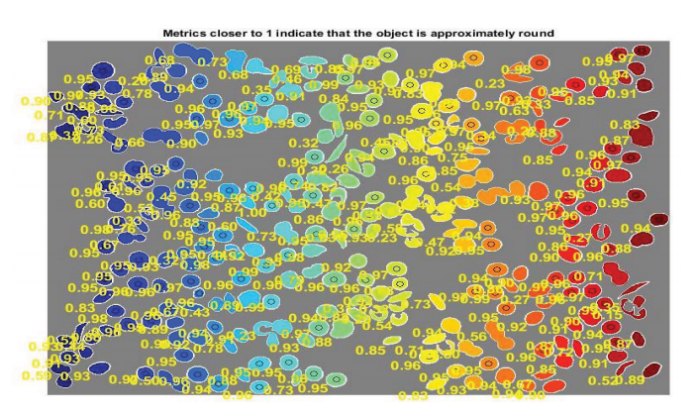

histogram equalization, contrast enhancement etc. are several

practises that exist for pre-processing of images.After reading the RGB input image in the MATLAB environment, it is transformed to gray scale. After that the image is fifiltered using a median fifilter to smooth the image.

1. ***Segmentation Using Niblack’s Thresholding***

In segmentation process the image is partitioned into different objects. In Sickle cell anaemia detection, the image is separated into foreground region with the aim to isolate the normal and abnormal RBCs and background region with the plasma. Image thresholding procedure is one of the vital ways for segmentation of image that separate the image into foreground and background regions. Here, Niblack’s thresolding method is applied to get the binary image from the gray level one. This effectively separates the cell image from its background. This local thresholding algorithm is based on calculation of threshold value using mean and the standard deviation by moving window about the location of each pixel.The native threshold at any given pixel (x, y) can be calculated by using the equation as given in Eq. (1),*NT (x, y)* = *m(x, y)* + *k* × *δ(x, y).*(1) Here, *m(x, y)* and *δ(x, y)* are the local mean and local standard deviation respectively. The quality of thresholded image determines with the value of *k* and the size of the sliding window. Based on the type of application, the size of the window varies. Segmentation result of binary image depends on the size of window [21]–[22]. Here, Fig. 3 shows the segmented image of Fig. 2 after applying Niblack’s thresholding.After Niblack’s thresholding, morphological operation has been applied on the image in order to remove the distortions and to make the object smooth. The holes in the binary image are also fifilled which refifines the border of the image. After that small objects have been removed from the binary image. The fifinal segmented image is shown in Fig. 4.

***D. Detection of Normal RBCs and Sickle Cells***

Geometrical Features are used to classify normal RBC and sickle cell from the segmented images. Here we estimate each object’s area and perimeter. Using these results a simple metric (form factor) is calculated that indicates the roundness of an object as given in Eq. (2). The value of this metric is equal to one for a circle and it is less than one for any other shape. *Form factor(Metric)* = 4

× *π* × *area*

*(perimeter*

*)*2

*.*

**III. RESULTS AND DISCUSSION**

In this section we will discuss how the targeted method is being implemented for achieving signifificant results in terms of detection of normal RBC and sickle cell. The Niblack’s thresholding is applied to the image data set. Then normal and abnormal RBCs are classifified calculating geometrical parameter *i.e.* form factor of each cell in the blood images. Fig. 6 shows the four microscopic blood images of sickle cell anemic person and their corresponding results after applying Niblack’s thresholding and calculation of form factor to classify normal and abnormal RBCs. In Fig. 6 form factor determines the classifification of normal and abnormal RBCs. The RBCs where form factor is nearer to 1 are detected as normal RBCs. For sickle cells value of form factor is nearer to 0.5. Thus using form factor the normal RBCs and sickle cells have been differentiated from the microscopic images.

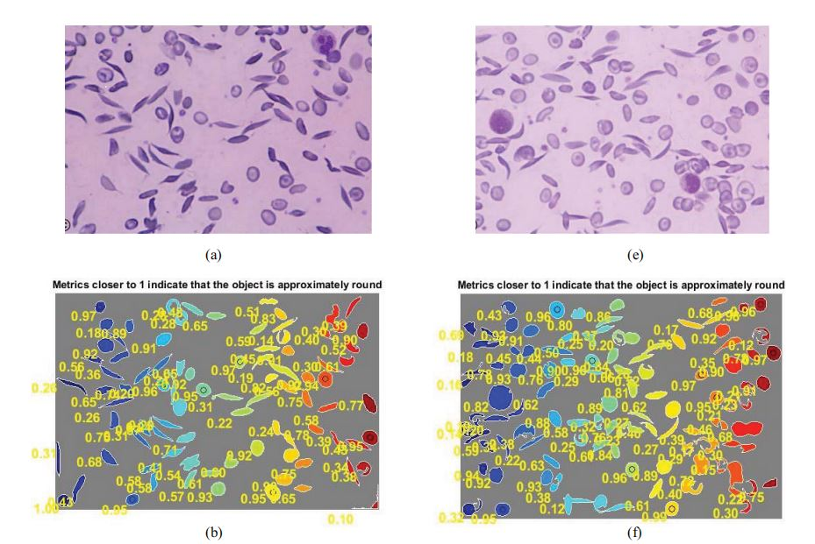

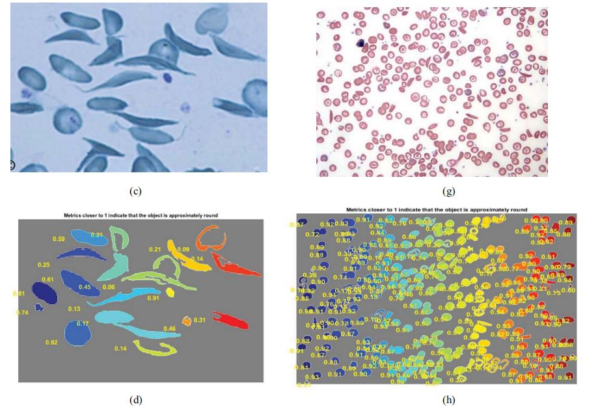

1. Image
2. (b) Detected normal RBCs and Sickle cells of image 1.

(c) Image 2. (d) Detected normal RBCs and Sickle cells of image 2. (e) Image

3. (f) Detected normal RBCs and Sickle cells of image 3. (g) Image 4. (h) Detected normal RBCs and Sickle cells of image 4.

1. **CONCLUSION**

In this paper, we have reported an approach by which the sickle cell anaemia can be detected with high effificiency. This work describes a local thresholding algorithm that removes background of an image of blood by using local mean and standard deviation. Niblack’s thresholding technique is implemented here for segmentation process on blood images. Although this method has been experimented in different applications, for detection of sickle cell anaemia it has been implemented afresh. This thresholding technique along with geometrical parameter (form factor) proves to be very much effective segmentation method in detection of normal RBC and sickle cell from microscopic blood images